**Develop A Web Application Using Node-RED Service**

### Python code for transferring latitude and longitude:

import time

import sys

import ibmiotf.application

import ibmiotf.device

import random

organization="mkgfko"

deviceType="raspberrypi"

deviceId="12345"

authMethod="token"

authToken="12345678"

try:

deviceOptions={"org": organization,"type": deviceType,"id": deviceId,"auth-method": authMethod,"auth-token": authToken}

deviceCli=ibmiotf.device.Client(deviceOptions)

except Exception as e:

print("caught exception connecting device:%s" % str(e))

sys.exit()

deviceCli.connect()

while True:

#in data

name="kowshik"

#lattitude=11.229592;

#longtitude= 78.171158;

#out data

lattitude=12.7345;

longtitude=13.2020;

data={'lat':lattitude,'lon':longtitude,'name':name}

def myOnPublishCallback():

print("published lattitude=%d" %lattitude,"longtitude=%d" %longtitude,"to ibm watson")

success=deviceCli.publishEvent("IotSensor","json",data,qos=0,on_publish=myOnPublishCallback)

if not success:

print("Not connected to IoTF")

time.sleep(3)

deviceCli.disconnect()

### OUTPUT:python output.png

PUBLISHED DATA IN IBM WATSON IOT PLATFORM:

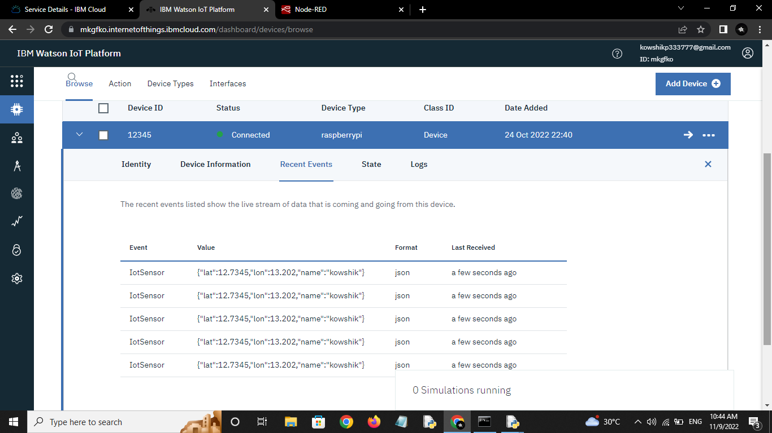

### WEB APPLICATION USING NODE-RED:

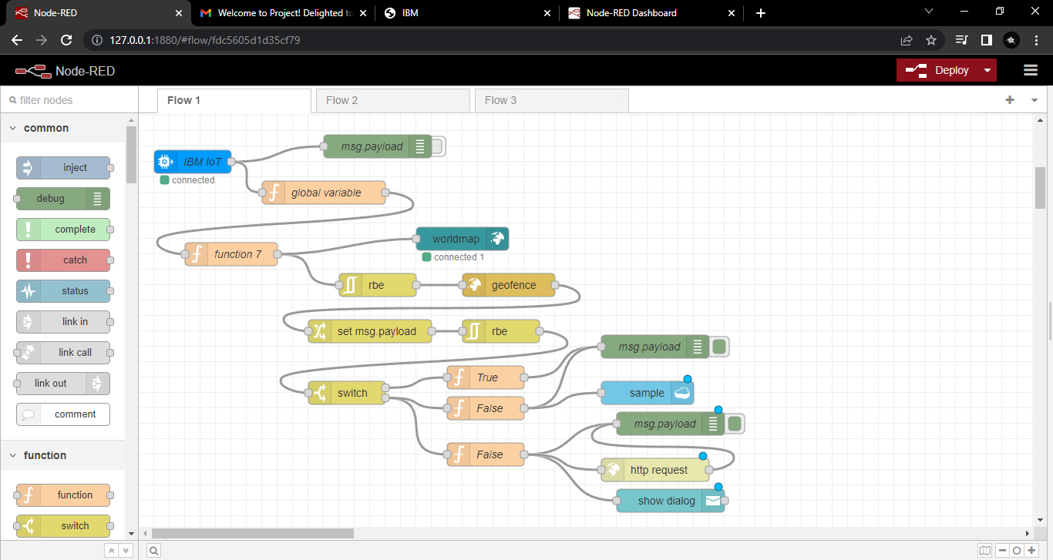

### WHEN WE GIVE IN AREA LOCATION:

### node red in area.png

### OUTPUT:

### in area web ui.png

### WHEN WE GIVE OUT AREA LOCATION:

### out area.png

### OUTPUT:

### out area web ui.png

## STORED DATA IN THE DATABASE WE HAVE CREATED:

## database data.png